# Introduction

Machine vision consists of both industrial and non-industrial systems, according to the Automatic Imaging Association (AIA), where a combination of hardware and software provides functional guidance to machines in the execution of their tasks by collecting information from image capturing and processing. In a wide variety of sectors, such as the electronics industry, the food and beverage industry and the healthcare industry, businesses use machine vision technologies to enhance and ensure quality, efficiency and operations(Marr, 2019). Machine vision has been used by some manufacturing facilities as early as the 1950s, but it began to bloom during the 1980s -1990s with new theories and concepts emerging, and it slowly became more common in manufacturing environments, leading to creation of the machine vision industry. LED technology of the industrial grade has been developed and developments in sensor operation and control design have been made, further driving the growth of the machine vision industry. Machine vision technologies continue to move forward today, and with 2D and 3D vision systems capable of scanning products at high speeds, these solutions are becoming more and more available, and systems can easily be found that do everything from thermal imaging to slope measuring. Industrial vision systems demand greater robustness, reliability and stability so that operation can go smoothly (“Cognex”, n.d.).

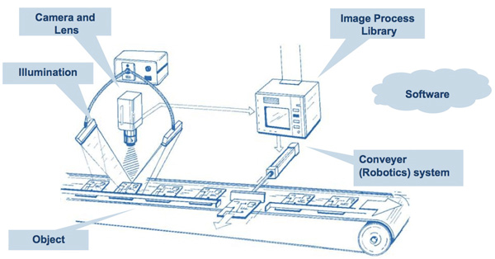

Figure 1: Machine Vision System Concept

# Machine Vision Systems

The typical components involved in machine vision systems are:

1. sensors
2. frame grabbers
3. Cameras
4. Lighting
5. software and computers capable of analyzing images, algorithms that can identify patterns, and finally an output such as a screen( Marr, 2019)

The process begins when the sensor senses a product's presence. In order to illuminate the area, the sensor then activates a light source (usually LEDs of different colours) and the camera can capture an image or several images of the product or part of the product. After that the images are saved onto a computer and are analyzed by the system software. The software can process the images first, then extract useful information which will be then used in the algorithm to identify defects. If a defect is detected, the product will fail inspection and will be separated from the rest of the batch. The process might seem simple enough to understand but each component has to be meticulously tuned according to the needs and requirements of the product or component, and the algorithms used in software can vary depending on the operation, thus machine vision is still advancing forward, and requires talents in both software and hardware to develop the technologies.

# Lighting

To establish a robust and reliable vision inspection, the proper use and standard of lighting are crucial factors. Before designing an effective and appropriate lighting solution, a thorough understanding and analysis of the inspection environment, which includes sample presentation, light interactions and knowledge of illumination techniques, filtering, geometry, types, sensor characteristics and colour. A reliable and stable lighting environment can be generated with comprehensive lighting analysis, which saves time and effort that can be used in other essential areas of a machine vision system, such as testing, architecture and implementation (Martin, 2019) .

There are three acceptance criteria for the most appropriate lighting for a given sample, which is to maximize the contrast on features of interest, reduce contrast on non-important areas, and provide a metric of robustness for the machine vision system (Martin, 2019).

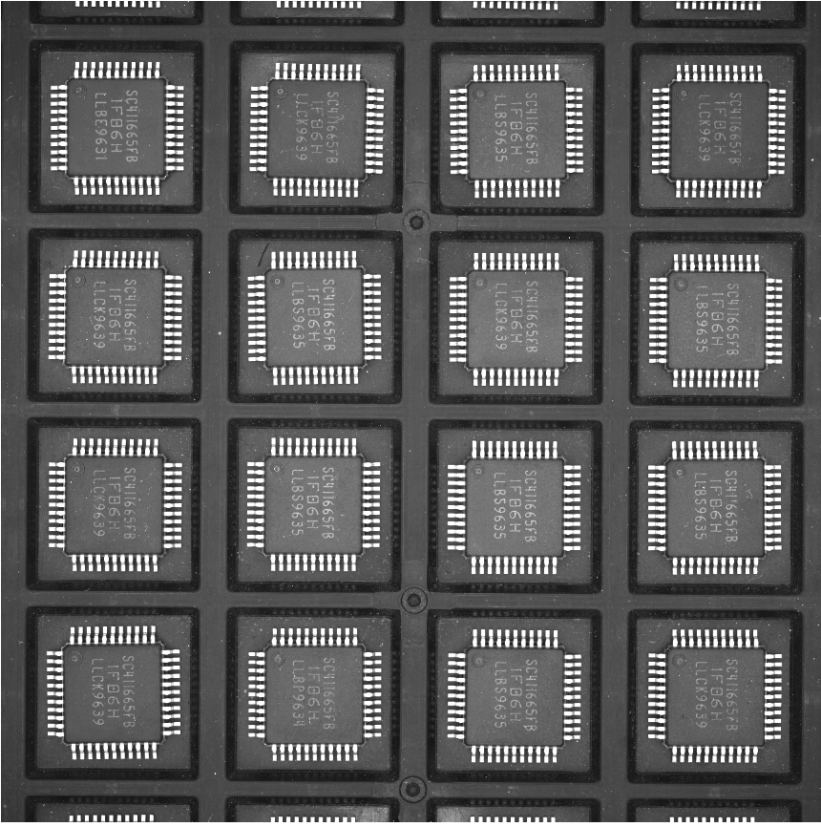

Figure 2: The image fits criteria 1 and 2because its region of interest has good contrast against the background. It fits criteria 3 because no matter how the operator places the packages, the image will have the same quality.

To meet these 3 criterias, there are 4 crucial variables that we have to control and manipulate. These 4 variables are geometry, structure or pattern, wavelength or colour and filter. Table 1 shows the definition of each variable. Understanding how to tune these 4 variables is crucial in meeting the 3 acceptance criteria for assessing quality and robustness of lighting. Glare, contrast and other responding variables are very much affected by the way we set these 4 variables.

|  |  |
| --- | --- |
| Variables | Definition |
| Geometry | The 3-D spatial relationship among sample, light and camera |
| Structure or Pattern | The shape of the light projected onto the sample |
| Wavelength or Colour | The way light is absorbed by the sample and the background |
| Filters | Blocking or allowing certain wavelength of light to pass through or changing of light directions |

Table 1: Definition of 4 important manipulating variables

Last but not least, we have to evaluate our sample and inspection environment during our lighting environment analysis to determine the sample and light interaction.

Once we assess the available lenses, methods, lighting types and four manipulating variables to satisfy the three acceptance criteria, the best lighting approach for the sample can be identified.

Next, we will look at the illumination techniques. It is to be noted that various lighting techniques can be used in conjunction together if it is appropriate to achieve optimal lighting environment. Back Lighting generates good contrast as it creates dark silhouettes of the sample against a bright background which makes it easy to identify any holes, gaps or even measure edges or objects. Precise edge detection also uses this technique by shining a monochromatic light ( red, green or blue) behind the sample.

Dome and Flat Diffuse Lighting creates even and multidirectional light that is mostly used on lightly curved, mixed reflective surfaces or shiny samples. Axial Diffuse Lighting is effective for flat samples, and does a good job of enhancing texture, angles or topographic features on flat samples.

The most popular vision lighting method used today is Partial Bright Field Lighting, and it can be seen by us everyday, which is sunlight. This technique generates good contrast and enhances topographic detail. However, this kind of light is not so good when used on shiny specular samples, as it will generate bright reflections.

Finally, according to Martin, Dark Field Illumination is regarded as the least well-understood of all techniques. It is possible to separate dark field lighting into circular and linear directional forms. Circular dark field lighting requires a specific light head geometry design. This type of lighting is characterized by low or medium angle of light incidence, typically requiring close proximity, particularly for the circular light head varieties.

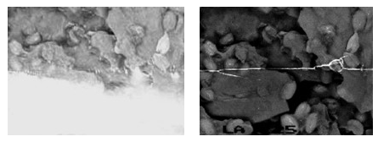

Figure 3: Bright field ring light (left) vs dark field ring light (right)

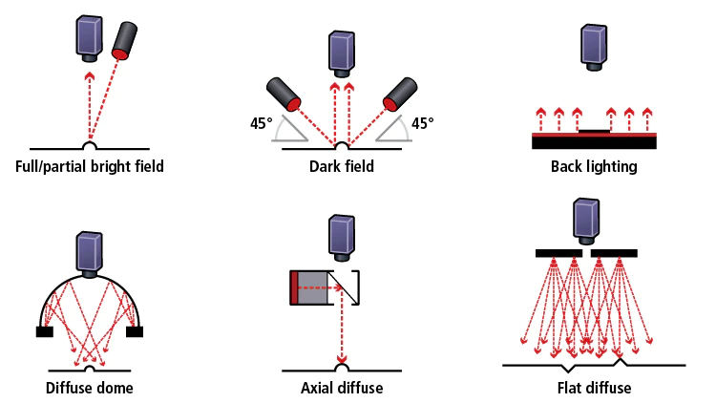

Figure 4: Types of machine vision lighting

# Cameras

Cameras in a machine vision system have to be carefully selected to achieve good image quality when capturing images of the sample. There are many different types and models of cameras in the market, but the types of cameras can be broadly grouped into 4 categories, high-resolution, high-speed, standard, and compact. We should be able to choose the perfect camera for our machine vision system if we consider the application criteria that needs to be satisfied by the cameras.

First, we could choose the camera based on resolution. A machine vision camera’s image sensor ( CCD or CMOS) is rows of light sensitive pixels placed onto a chip, with a cover glass on top to protect the pixels. The standard pixel resolution is 310k pixel or 640 x 480, while high-resolution types are usually within the range of 2 to 21 megapixels. As a general rule, it is best to choose a camera depending on the field of view and pixel resolution needed. The field of view, which is also the area captured by the lens, can be altered by changing the lens used.

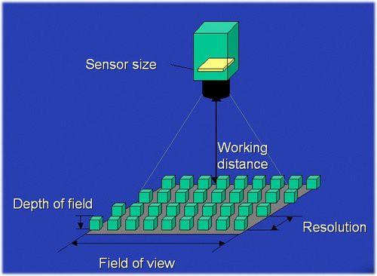

Figure 5: Important parameters to consider when choosing camera for machine vision systems

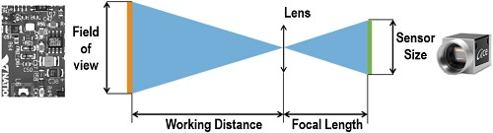

Figure 6: simplified version of Figure 5

Pixel resolution can be defined as to how many millimeters per pixel, and the relationship can be expressed as below.



To show how this works, let’s assume we need a 30 mm 1.18" (1.18 inches = 30mm) field of view in direction Z for our machine vision system application. We will use image sensors standard 310k pixels (Z = 480p) and the general-purpose high resolution 2MP (Z = 1200p). The calculations are shown below.



As this example shows, if we know the desired pixel resolution, the desired field of view, and the pixel count of our image sensor are able to be measured. Another two parameters that we have to pay attention to is detection capability and dimension tolerance. These two parameters are important when performing pass or fail judgement on appearance inspections, and dimensional inspections.



As an example, we will test the detection capability of a 2 megapixel camera.



This measurement indicates that a camera with a resolution of 2MP or more is needed if the sample is as small as 0.1 mm 0.004" with a field of view of 30 mm 1.18".

Second, we can select the camera based on colour or monochrome type image sensor. In general, if the difference is observed based on hue at points on the sample, then colour cameras have an edge over monochrome cameras. However, monochrome cameras do have other advantages over colour cameras. Monochrome cameras work very well when there is a large contrast between the sample and the background, such as dimension measurement using a backlight. Another factor to note is that colour cameras use a Bayer filter (each pixel relies on adjacent pixels to get maximum colour information), which makes them less reliable for dimensional type calculation using edges than monochrome cameras. (“keyence”, n.d.).

Third, we can choose the camera for our machine vision system based on image transfer speed. Cameras can have different image transfer speeds, regardless if they have the same pixel count. As an example, a standard 310k pixel camera takes about 16ms to transmit an image, while high-speed models of the same pixel resolution can achieve speeds of up to 1.7ms. To achieve higher speeds, partial capture function can be used. High-speed cameras are great for machine vision applications where speed is critical. High-speed cameras can be used to allow more time for image filtering and processing for normal speed applications, or even faster inspection cycle time (“keyence”, n.d.).

Lastly, we can select the camera based on the camera size. Compact cameras can have the same specifications as larger cameras, while being smaller, which is good for machine vision systems with limited installation space. It is important to take into consideration the lens size, camera size, cable space, and distance between the lens and the workpiece when setting up a sample-appropriate machine vision environment (“keyence”, n.d.).

|  |  |
| --- | --- |
| Features | Criteria |
| Pixel Resolution | High or Low |
| Sensor type | Colour or Monochrome |
| Image Capture Speed | Fast or Normal |
| Camera Size | Compact or Normal |

Table 1: Summary of features to consider when choosing camera

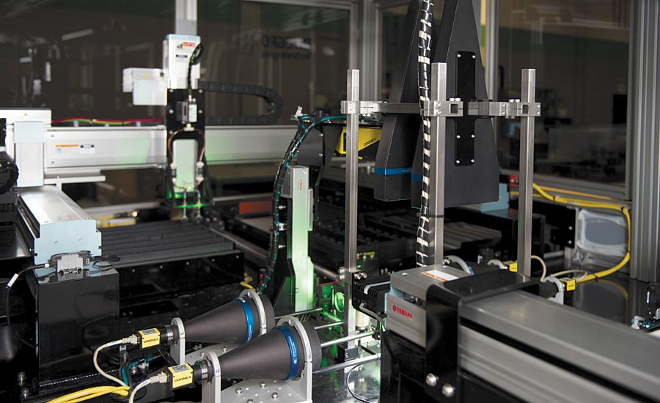

Figure 5: Inspection machine vision system

# Application

Machine vision supports companies from diverse sectors as essential instruments for recognition, inspection, guidance and more, as well as for quality management purposes.

Firstly, machine vision systems can be used in correcting production line defects. Machine vision is able to be set up to identify where the problems in a production line are being introduced, and action can be taken based on this information to correct the problem.

Second, harvesting machines often use machine vision to detect the position of grapes on the vine. This allows them to carefully harvest a bunch of grapes without squishing them. Machine vision can also be set up in a farm to monitor crops, or detect whether the plant has disease or not.

Thirdly, machine vision can help in the monitoring and managing of inventory. By reading barcodes and tags on parts and goods, machine vision can do this, and measure stock and inventory without human power. It is also used in the food and beverage and pharmaceutical industries to catalogue products, product serial numbers, and track expiration dates.

Last but not least, machine vision systems are able to make measurements and calibration just by capturing an image of the component or product to be measured. The process is automated and can happen very quickly which saves time and resources.

# Reference

1. B. Marr. (2019). What is Machine Vision And How Is It Used In Business Today?. Retrieved from <https://www.forbes.com/sites/bernardmarr/2019/10/11/what-is-machine-vision-and-how-is-it-used-in-business-today/?sh=6158f2e16939>.
2. “Cognex”. n.d. What is Machine Vision?. Retrieved from <https://www.cognex.com/en-my/what-is/machine-vision/what-is-machine-vision>
3. D. Martin. (2019). A Practical Guide to Machine Vision Lighting. Retrieved from <https://www.ni.com/en-my/innovations/white-papers/12/a-practical-guide-to-machine-vision-lighting.html>
4. “Keyence”. n.d. Select the Correct Camera. Retrieved from https://www.keyence.com/ss/products/vision/visionbasics/tips/primer1/